Thaxted/Little Easton Walk
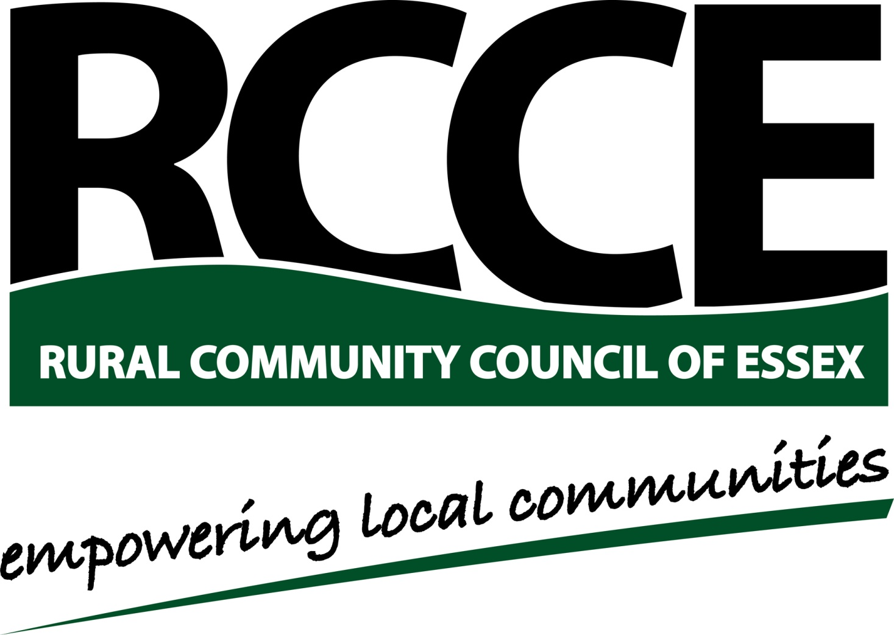

2nd April 2016

In aid of the Essex Rural Fund

We would welcome your company, and your family and friends, on our walk. To help us plan and cater please indicate here how many of you are able to join us for the walk / lunch:

Please also fill in your details and return the form to the address below. Both feet and paws welcome! We would like to have your email address, is possible, as this will enable us to reduce the cost of keeping in touch in the future.
Name:
Address
Postcode:
Tel. Email:

Unable to Come?

If you are unable to join us on the day but would still like to support us you might consider making a donation to the Essex Rural Fund. It can be made:
- On-Line: visit Just Giving page http://www.justgiving.com/Essex-Rural-Fund and follow instructions.
- By Cheque: Please complete the details below and return the form with your donation. Cheques payable to Essex Community Foundation – Essex Rural Fund
- By Bank Transfer: To Essex Community Foundation, sort code 60-05-13, account number 89385195, please add a reference “Rural Fund”
- By gift of shares: Please contact Essex Community Foundation to discuss how you can donate a gift of shares to Essex Rural Fund on 01245 355947 or email: general@essexcf.org.uk
I would like to make a donation of £

Please tick here if you are a UK tax payer and would like Essex Community Foundation to reclaim Gift Aid on this, and any future donations.

Please return this form to: David Boyle, Fairstead Hall, Fairstead, Chelmsford, CM3 2AT. Any queries to him on 01245233435 or david@fairsteadhall.plus.com

